**Experiment: 2.3**

**Student Name:** SANJIV GUPTA **UID:** 21BCS-*3478*

**Branch:** CSE **Section/Group:** 21BCS-IOT-602B

**Semester:** 5th **Date:** 19/10/23

**Subject Name**: AIML Lab **Subject Code:** 21CSH-316

1. **AIM:** *Implement K-Nearest Neighbor on any data set.*
2. **Objective:**

* *To Learn about Meta-data and different clustering functions.*
* *To learn About Different KNN Techniques.*
* *To Learn about Cluster Model or algorithms.*

1. **Tools/Resource Used:**

*1. Python programming language.*

*2. Jupyter Notebook.*

1. **Algorithm:**

*1. Importing the modules*

*2. Creating Dataset*

*3. Visualize the Dataset*

*4. Splitting Data into Training and Testing Datasets*

*5. KNN Classifier Implementation*

*6. Predictions for the KNN Classifiers*

*7. Visualize Predictions.*

1. **Program Code:**

*import numpy as np*

*import pandas as pd*

*import matplotlib.pyplot as plt*

*from sklearn.datasets import make_blobs*

*from sklearn.neighbors import KNeighborsClassifier*

*from sklearn.model_selection import train_test_split*

*X, y = make_blobs(n_samples = 500, n_features = 2, centers = 4,cluster_std = 1.5, random_state = 4)*

*X_train, X_test, y_train, y_test = train_test_split(X, y, random_state = 0)*

*knn5 = KNeighborsClassifier(n_neighbors = 5)*

*knn1 = KNeighborsClassifier(n_neighbors=1)*

*knn5.fit(X_train, y_train)*

*knn1.fit(X_train, y_train)*

*y_pred_5 = knn5.predict(X_test)*

*y_pred_1 = knn1.predict(X_test)print("Mean of the array is", mean)*

*plt.figure(figsize = (15,5))*

*plt.subplot(1,2,1)*

*plt.scatter(X_test[:,0], X_test[:,1], c=y_pred_5, marker= '*', s=100,edgecolors='black')*

*plt.title("Predicted values with k=5", fontsize=20)*

*plt.subplot(1,2,2)*

*plt.scatter(X_test[:,0], X_test[:,1], c=y_pred_1, marker= '*', s=100,edgecolors='black')*

*plt.title("Predicted values with k=1", fontsize=20)*

*plt.show()*

1. **Output/Result:**

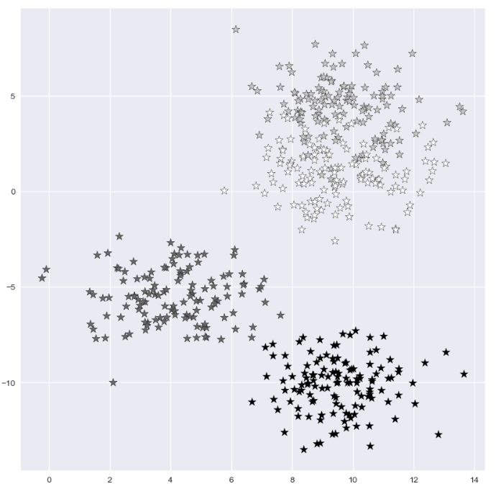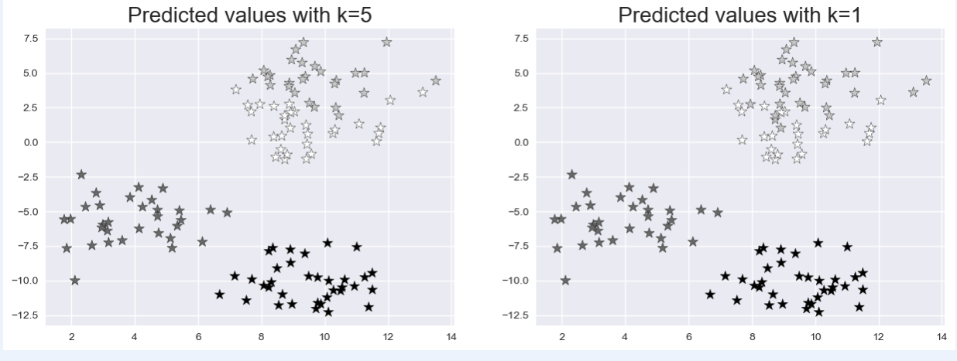

1. **Learning Outcomes:**
2. *Implement to implement different python library.*
3. *Understand the concept of k-mean.*
4. *Learn machine learning algorithm.*